Carbon Reduction Plan
Supplier name: Octapharma Limited
Publication date: 15th December 2025
Carbon Reduction Plan URL and PDF version can be found here

Commitment to achieving Net Zero

Octapharma is committed to achieving Net Zero emissions by 2050.

Baseline Emissions Footprint

Baseline Year: 2019
Additional Details relating to the Baseline Emissions calculations.

Octapharma Ltd has selected 2019 as our base year since it represents our typical pre-pandemic operations. Our calculation includes Scope 1,2 and 3 emissions data collected from our sites and partners. An external organisation assisted us in understanding our emissions categories, performing the calculations, and validating our data.

Our business operates from two sites: a leased office and a warehouse. The warehouse, which contains a large freezer, is regularly maintained and checked for leaks, with no leaks recorded in 2019. Our frozen product is delivered using polystyrene packaging and dry ice, which require significant volumes due to the fragile nature of our products. Special consideration was given to these items in our calculations.
The following emissions categories have been assessed using relevant industry conversion factors and calculation standards.

Electricity and gas usage

Upstream and downstream transport and distribution

Purchased goods with a focus on polystyrene and dry ice purchases

Employee commuting

Business travel

Capital goods

Water and waste

Any recorded freezer leaks

Baseline year emissions:
EMISSIONS | TOTAL (tCO₂e)
Scope 1 | 73
Scope 2 | 7
Scope 3  (Included Sources) | 156
Total Emissions | 236

Current Emissions Reporting
Reporting Year: 2024
EMISSIONS | TOTAL (tCO₂e)
Scope 1 | 116
Scope 2 | 14
Scope 3  (Included Sources) | 60
Total Emissions | 191

Emissions reduction targets

To continue our progress to achieving Net Zero, we have set the following carbon reduction targets:

Since 2019, we have reduced our overall emissions by 19% and aim to achieve a 30% reduction by 2028.

We project that carbon emissions will decrease to 167 tCO₂e by 2028, representing a 12% reduction from 2024 levels.

Progress against these targets is illustrated in the graph below:

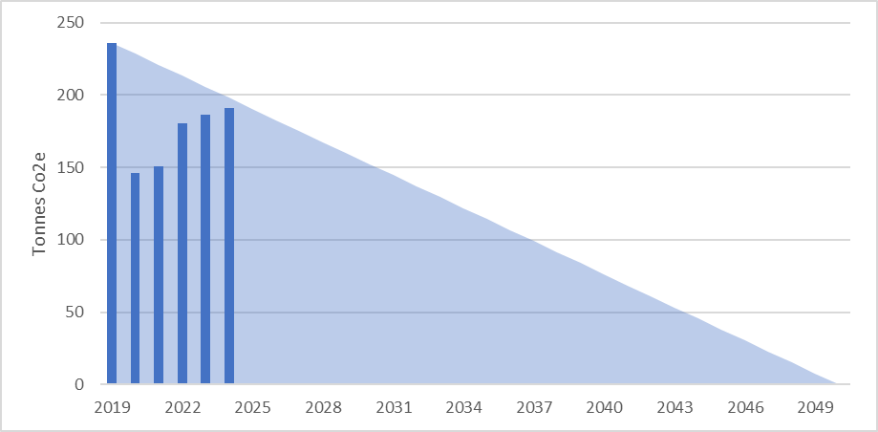

Carbon Reduction Projects
Since our 2019 baseline, we have implemented several environmental management measures and projects, achieving a carbon emission reduction of 51 tCO2e, which is a 22% reduction.

• Changed internal policy to promote online meetings
• Modified sales process to reduce travel time
• Introduced an electric car scheme for employees
• Launched a bike-to-work scheme
• Moved to modern, efficient offices
• Increased service and maintenance of the freezer to improve efficiency
• Reduced procurement of dry ice

We have set long-term (2050) and short-term (2030) decarbonisation targets. In the short term, we have enhanced freezer maintenance to reduce refrigerant leaks, which significantly impacted our performance in recent years. We will continue to encourage car sharing, pub-lic/electrified transport, and online meetings. We aim to remain energy-conscious across our sites, minimise waste, and ensure efficient transportation.

Long-term, we plan to phase out dry ice usage by 2050, which will significantly change our operations. We forecast a significant drop in emissions from employee commuting as electric cars are adopted. Additionally, the decarbonisation of the UK power and logistics sectors will impact our emissions. We also plan to lease 100% renewable electricity for our office space. Our current plan does not achieve zero emissions by 2050 due to necessary refrigeration. Any residual carbon will be offset through a reputable offset program.

Declaration and Sign Off
This Carbon Reduction Plan has been completed in accordance with PPN 06/21 and associated guidance and reporting standard for Carbon Reduction Plans.
Emissions have been reported and recorded in accordance with the published reporting standard for Carbon Reduction Plans and the GHG Reporting Protocol corporate standard and uses the appropriate Government emission conversion factors for greenhouse gas company reporting.
Scope 1 and Scope 2 emissions have been reported in accordance with SECR requirements, and the required subset of Scope 3 emissions have been reported in accordance with the published reporting standard for Carbon Reduction Plans and the Corporate Value Chain (Scope 3) Standard.
This Carbon Reduction Plan has been reviewed and signed off by the board of directors (or equivalent management body).

Signed on behalf of the Supplier:


Date: 15th December 2025

https://ghgprotocol.org/corporate-standard
https://www.gov.uk/government/collections/government-conversion-factors-for-company-reporting
https://ghgprotocol.org/standards/scope-3-standard

